**PROJECT PLANNING**

The project management life cycle is depicted and documented in the form of a Gantt Chart, which allows HanSen personnel to adhere to the rules and meet milestones on a regular basis. The project life cycle WBS divides each member's role and work, such as the project manager, into many modules. Based on the WBS, each member has their own duties and responsibilities at each point of the lifecycle.

**Project Management WBS is shown in the Gantt Chart below:**

|  |  |
| --- | --- |
| PROJECT TITLE | Smart Lock With Integrated Advanced Recognition |
| PROJECT MANAGER | AMIRUL IAN RASHIDEE BIN MOHD JASNI |
| COMPANY NAME | HanSen Incorporation |
| DATE | 29/11/2022 |

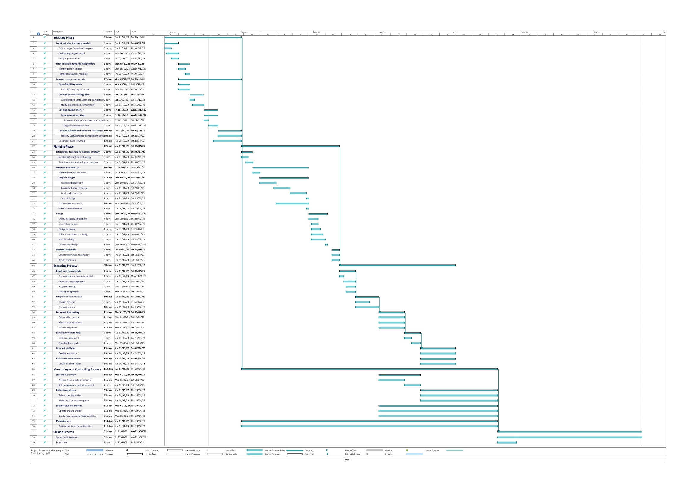

**Smart Lock With Integrated Advanced Recognition Work Breakdown Structure (WBS):**

**SCOPE**

A work breakdown structure (WBS) is constructed to map out all of the essential activities and to design the process that will be maintained and authorised by the WBS.

**RISK IDENTIFICATION CHART (Quality, Cost, Time)**

|  |  |  |  |
| --- | --- | --- | --- |
| **Control Element** | **What is likely go wrong?** | **How and When will I know ?** | **What will I do about it ?** |
| **Quality**  (Poor quality mindset; poor design, materials, and craftsmanship; insufficient quality assurance of product) |  |  |  |
| **Cost**  (Estimating errors; inadequate productivity, cost, change, or contingency) |  |  |  |
| **Time**  (Faults in forecasting time or resource availability; errors in establishing the critical route; insufficient float allocation and management; early release of competitor goods) |  |  |  |

**RESPONSIBILITY ASSIGNMENT MATRICES (RAM)**

|  |
| --- |
|  |

|  |  |  |
| --- | --- | --- |
| Roles | Person In Charges | Responsibilities |
| Project Manager | Amirul ian Rashidee bin Mohd Jasni | For all project office management operations, the Project Manager reports to the Project Director. The Project Manager develops, directs, and supervises the day-to-day internal operations that support the Project Office, as well as assisting in the formulation of the master project schedule and all other project work plans. In addition, the project manager must ensure that all initiation and planning papers, such as the Work Breakdown Structure (WBS) and Gantt chart, are produced in a clear and thorough manner.  Nextly, The Project Manager is responsible for the creation, upkeep, and adherence to the Project Office infrastructure and supporting methods (e.g., processes, procedures, standards, and templates) that are in accordance with OSI Best Practices and policies. The project Smart Lock with Integrated Advanced Recognition must also be monitored to ensure that it is progressing in accordance with the project scope and requirements. If a problem arises, the project manager must take corrective action. |
| Procurement Manager | Muhamad Faris Bin Awal | The Procurement Manager directs and controls the creation of the RFP or RFO and associated solicitation documents. Other parts of the project office may be allocated responsibility for individual aspects, but the Procurement Manager is responsible for integrating all of the elements, ensuring consistency and continuity throughout the procurement process, and adhering to procurement standards, norms, and regulations. This includes overseeing the formulation of the RFP or RFO, developing and maintaining a procurement timeline, coordinating contract negotiations, and managing the review of proposals or offers and vendor selection.  In addition, Procurement Manager must negotiate the project's contract, policies, and deadlines with each of the members. Furthermore, the procurement manager must ensure that no employees purchase any company-related items using corporate funds. Every expenditure must be approved by the procurement manager. |
| Risk Manager | Abdullah Harith Bin Jamadi | The Risk Manager is in charge of managing and tracking risks, as well as risk mitigation and contingencies on the project. The Risk Manager also oversees prime contractor risk management activities to ensure they do not endanger the project. The Risk Manager manages and tracks potential and active risks, maintains the risk management tool and documentation information, leads project risk identification sessions, monitors prime contractor risk management efforts, and participates in division-level risk management activities for risks that cross project boundaries or are beyond the project's control.  Any risks in this project must be documented. For example, in Smart Lock, the developer must extract both the owner's face and fingerprint. However, noise from camera dust, water, and other sources will make detection difficult.  Every stage of this project may encounter unanticipated difficulties. As a result, the risk management must record each and every risk so that they can avoid and take precautions to ensure that the problem does not occur. |
| Administrative Manager | Muhammad Muhazill Daniel Bin Hassan | The Administrative Manager leads the cost management effort, which includes sponsoring cost budgeting and monitoring activities, encouraging communication on fiscal status, and ensuring the project cost tool and accompanying paperwork are maintained. The Administrative Manager also offers reports, recommendations, and status updates on the project budget and expenditures, such as planned vs. actual reports, as well as initiates corrective action and re-planning operations.  Following each phase in the Smart Lock project, the administrative manager must make a list of everything that can be supplied in the documentation form. For example, the activity report and associated expense paperwork. This function is critical in ensuring that everyone and everything follows a standard method as documented, as well as avoiding time and money waste. |
| Financial Analyst | Muhammad Muhazill Daniel Bin Hassan | The Financial Analyst by side Administrative Manager by supporting cost management effort which is sponsoring cost budgeting and monitoring activities, encouraging communication on fiscal status, and ensuring the project cost tool and accompanying paperwork are maintained.  The Financial Analyst also provide support in project validations, in evaluate the project and assisting in the evaluation of the cost based on the project. It also covered and identify the main challenges in evaluating project to make sure that project didn’t cross budget. |
| Project Scheduler | Muhammad Muhazill Daniel Bin Hassan | The project scheduler's job is to coordinate and manage the inputs to the plan, which includes monitoring progress against the project schedule, merging and figuring out how the project schedule is dependent on other schedules, and monitoring progress on the schedule of the prime contractor and the schedules of the counties.  In order to prevent system development from spiralling out of control and to mitigate unforeseen risk brought on by delays or interruptions in the progress, the project scheduler's job is to design the progress flow and track it. |
| Quality Manager | Abdullah Harith Bin Jamadi | A quality manager requires to take full responsibility during the implementation and execution, testing and evaluation to ensure the quality product requires is achievable. By observing the inspections data, it helps in better analysis throughout the industry’s needs.  An amazing quality manager need to know their products well, as they go through everything. It also important to have good leadership as they will large number of teams in different sections.  Quality manager also needs to be able in handling lines’ of staff and dealing with customer professionally to preserve the relation. |
| Stakeholder Coordinator | Abdullah Harith Bin Jamadi | Stakeholder coordinator also known as stakeholder manager need to be able to both develop and maintain professional relationships with stakeholder as it will provide opportunities in engagement strategies.  Business unit should handle effectively by stakeholder coordinator by following the firm’s stakeholder engagement guidelines provided to allow equity principles and stakeholder satisfaction to be achieved. |
| Technical Manager | Abdullah Harith Bin Jamadi | Technical manager is person who are fully responsible in oversees the development of the project management. Any technicality and potential issues should be handles carefully as it will result the outcome of the project.  It is required to provide clear direction and guideline to successfully achieve deliverable at any cost. Technical manager also need to regulate testing time to time on the system to consider any evaluations or improvements while providing strategies on tackling any unexpected issues. |
| Implementation Manager | Muhammad Muhazill Daniel Bin Hassan | The Implementation Manager will be in charge of the project's implementation component and will provide leadership in terms of planning, organising, coordinating, and overseeing implementation activities. Along with managing the implementation strategy, organisational change management, production support, IT training, defect or problem tracking, and Maintenance & Operation, the Implementation Manager is also responsible for managing all information technology resources assigned by the Project Manager. To make sure that technical duties meet all goals and expectations, the implementation manager will organise SOWs and interact directly with contractors.  The Implementation Manager will act as a liaison between the project leader and the system developer on the Smart Lock with Integrated Advanced Recognition system project in order to establish communication between them. This will involve passing along instructions from the manager and assisting in overseeing the developer's work. |
| Test Manager | Muhamad Faris Bin Awal | The Test Manager is in charge of supervising the testing of the Prime Contractor's system. The Manager collaborates with the Quality Management team to create test cases and data that best replicate "real-life" circumstances for the system. The Test Manager is also in charge of organising interface testing with other entities (county, state, and federal) as needed. They plan, monitor, and assess prime contractor test plans, as well as the issue reporting and resolution process. |
| Operations Manager | Muhamad Faris Bin Awal | The Operations Manager is in charge of coordinating and supervising the new system's operations. Any remedies to difficulties encountered throughout the project must be approved by the project's operations manager. For example, if they are having trouble extracting the fingerprint feature from a picture or creating the model for facial recognition, the operation Manager has the authority to decide what action to take, whether to upgrade the system in terms of hardware or software. Not only that, but the operation Manager is also in charge of administration and operations. The operation manager for the Smart Lock With Integrated Advanced Recognition project is responsible for ensuring that everyone on the team is doing their job appropriately. |
| Customer Support Manager | Amirul ian Rashidee bin Mohd Jasni | The Customer Support Manager is in charge of supervising M&O Contractor support activities as well as assisting customers with unique requests or concerns. The Customer Support Manager is responsible for monitoring contractor service levels and metrics, as well as providing customer perspective and problem priority.  The project's support manager must assist customers in answering questions and frequently ask questions through any methods. For example, email, phone, and social media conversation. This function is critical because it makes customers feel welcomed and important. |
| Executive Steering Committee | Amirul ian Rashidee bin Mohd Jasni | The Executive Steering Committee serves as the project stakeholders group, ensuring that the project's deliverables and functionality are met as outlined in the project initiation documents and subsequent project management plans. This committee provides high-level project direction, receives project progress updates, and addresses and resolves issues, risks, or change requests.  Furthermore, the Executive Steering Committee must make judgments regarding our project's financial management. He assesses progress against the particular objectives, milestones, and deliverables of each work page. |
| VC Jewelry Goldsmith  Representative | Amirul ian Rashidee bin Mohd Jasni | The VC Jewelry Goldsmith Representative serves as a liaison between the Project Office and the VC Jewelry Goldsmith, assisting the project in determining the feasibility of services, cost estimates, planning, and other technical assistance to assist the project in making informed data centre decisions.  This function is critical since it will assist our organisation in determining which technologies and stacks are crucial. We can only examine risk management and assessibility after determining the technology stack and requirements. As a result, VC Jewelry Goldsmith is critical in ensuring a company's optimal technological stack and cost. |